Mr. Ritik Patidar Date:25/10/2022

Email:- ritikpatelll998266@gmail.com

**Sub:-Offer letter for the position "Software Developer (Java)."**

Dear Ritik,

On behalf of I-ON Infotech. I am pleased to confirm our offer of employment to you as Software developer (Java) based in Pune Maharashtra, India.

We extend this offer, and the opportunity it represents, with great confidence in your abilities. Your immediate manager will communicate details of your role and work responsibilities in the initial weeks of your joining I-ON Infotech. We mutually agree to a start date of 01st November 2022.

Your employment with us will be governed by our Terms and Conditions which will be given to you along with your appointment letter. You will also be governed by any rules, regulations, policies and practices that may change from time to time.

**Salary**:- Your monthly compensation will be INR 10000/- (ten thousand Only). And other incentive and allowance according to commitment. The details are confidential and you may discuss it only with the undersigned in case of any clarification. After completion your given target you will get incentive.

It is our hope that your acceptance of our offer will be just the beginning of a mutually beneficial relationship with our Company.

Notice period is the time period served in the company after resigning from the job. 15 days to serve in notice period. The offer letter should clearly state the notice period required to be served in the company in the event of the resignation by the employee.

**Note:** By accepting this offer, you acknowledge that this information must remain confidential and agree to refrain from using it for your own purposes or disclosing it to anyone outside of **I-ON Infotech**,

We look forward to having you begin your "Software Developer (Java)" at **I-ON Infotech**. and wish you a successful career. Welcome to our team!

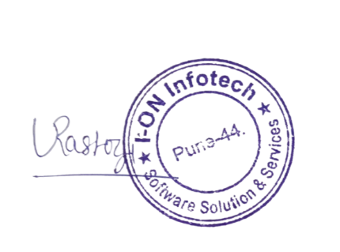With Best Wishes, for

**I-ON Infotech**

Authorized Signatory

**Acceptance:**

I.............................................accept the position on the terms and conditions of employment offered. I will provide the following

documents on the day of joining: 1. Passport Copy 2. Copy of Educational Certificates 3. Service/ Relieving letter from existing employer 4. Last drawn three months' pay slips (if available) 5. PF Number (if available) 6. PAN Number 7. Form 16 from existing employer (if available) 8. Two color passport photographs. 9.Bank Passbook front page photo.

Full Name ..............................................

Signature................................................

**Certificate**

**TO WHOM IT MAY CONCERN**

This is to inform you that Mr Ritik Patidar is employed in our company as a "Software Developer (Java)" in Technical department of the company from 01st November 2022 to 07th February 2024.

He has always had a good working relationship with his team members and supervisors.

We wish him to best of luck for his future endeavors.

Date: - 15.02.2024

Sincerely,

**Authorized Signatory**

Managing Director

Arjun Madhav

I-ON Infotech